P022- Azure Automation Runbooks for VM Start and Stop Schedules

Created a Resource Group and in that resource group we created resources
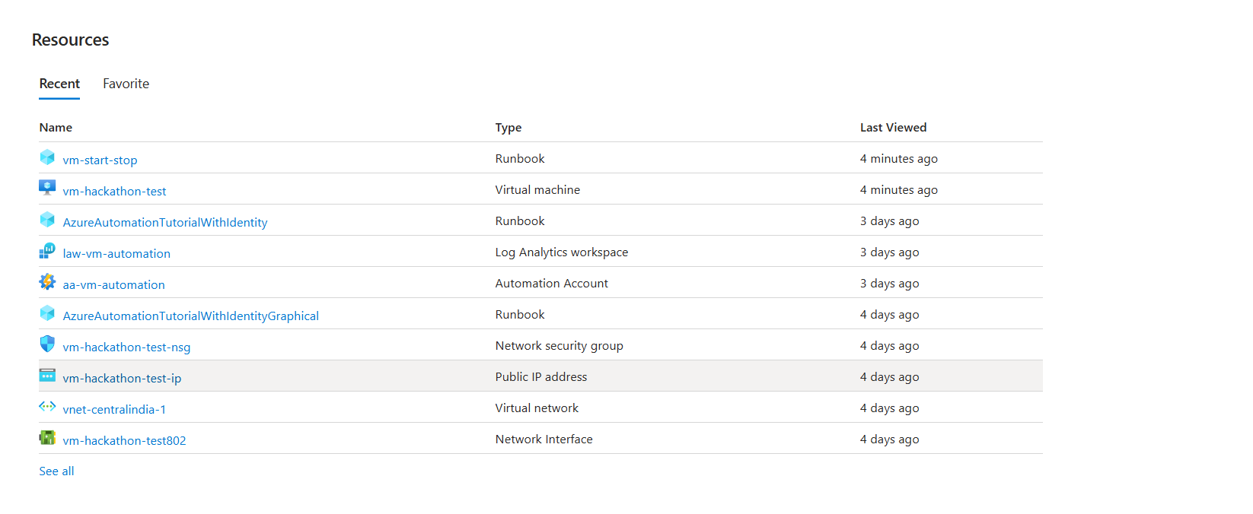
This is the virtual machine which is in stop state
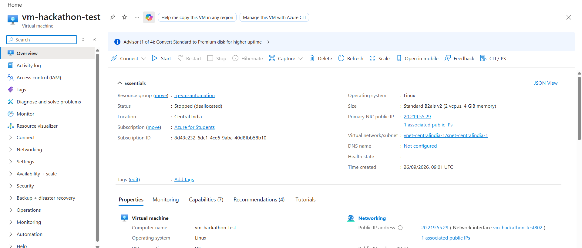
Created run book and running the book with passing parameter (action=”start”) so that virtual machine will be started.
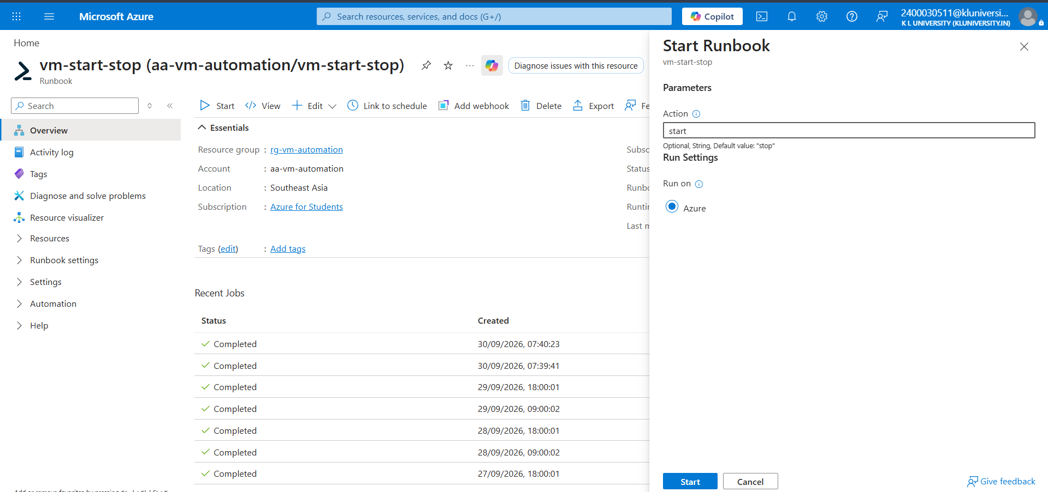
Actually above process should be done automatically by schedule.
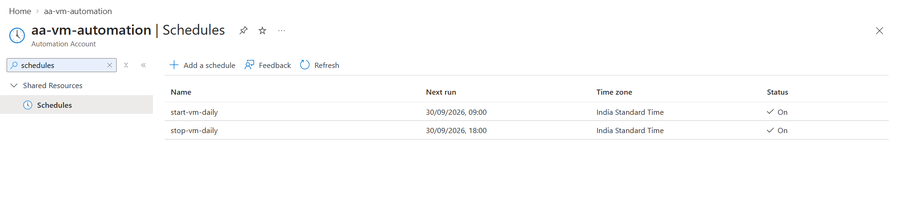
See, the virtual machine goes from stopped state to starting state
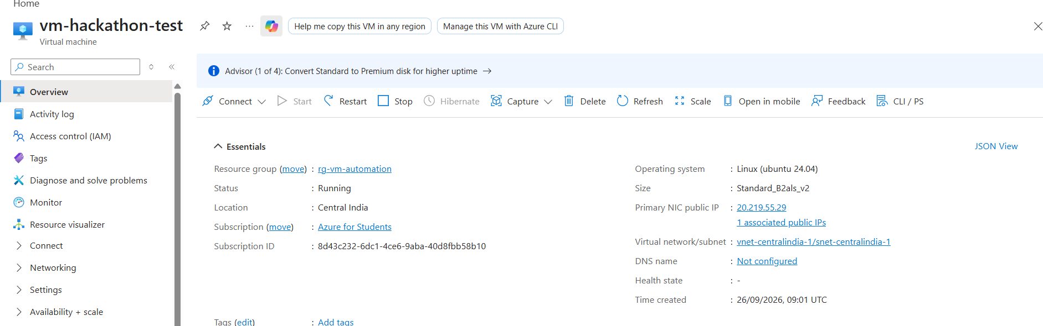
This is the powershell commands , our team used for run book
param(
[string]$Action = "stop"
)
Connect-AzAccount -Identity
$resourceGroupName = "rg-vm-automation"
$vmName = "vm-hackathon-test"

if ($Action -eq "start") {
Start-AzVM -ResourceGroupName $resourceGroupName -Name $vmName
Write-Output "VM started successfully."
}
elseif ($Action -eq "stop") {
Stop-AzVM -ResourceGroupName $resourceGroupName -Name $vmName -Force
Write-Output "VM stopped successfully."
}
else {
Write-Output "Invalid action. Use 'start' or 'stop'."
}

